**Microsoft word**

**What is MS Word?**

Sometimes it called Winword, MS Word, or Word.It has advanced features which allow you to format and edit your files and documents in the best possible way. Originally developed by Charles Simonyi and Richard Brodie, it was first released in 1983. Microsoft Word is a word processor published by Microsoft.

**What are the uses of MS Word?**

Microsoft Word can be used for a variety of tasks:

* Creating business papers with a variety of images, such as photos, charts, and diagrams.
* Saving and reusing pre-formatted text and elements like cover pages and sidebars.
* Making letters and letterheads for both personal and professional use.
* Creating a variety of documents, including resumes and invitation cards.
* Producing a variety of letters, ranging from simple office memos to legal copies and reference documents.

**Example Of Home**

**Multilevel List**

**Numbering**

**Bullet**

**Font Control**

**Font size**

Subscript

**Superscript**

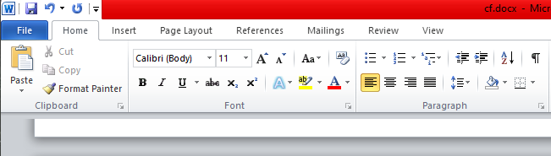

**Te­xt-Align: Justify**

**Text-Align: Right**

**Text-Align: Center**

**Text-Align Left**

**Font Color**

**Strikethrough**

**Underline**

**Italic Style**

**Bold**

A table is a grid of cells arranged in rows and columns. Tables are useful for various tasks such as presenting text information and numerical data. In Word, you can create a blank table, convert text to a table, and apply a variety of styles and formats to existing tables.



Insert a picture in Word, PowerPoint, or Excel

Click the location in your document where you want to insert a picture. **On the Insert tab, click Pictures**. Select the option you want to use for inserting pictures.



To add a shape, **click Insert, click Shapes, select a shape, and then click and drag to draw the shape**. After you add one or more shapes, you can add text, bullets, and numbering to them, and you can change their fill, outline, and other effects on the Format tab.



A SmartArt Style is **a combination of effects, such as line style, bevel, or 3-D**, that you can apply to the shapes in your SmartArt graphic to create a professional look. Click your SmartArt graphic. On the Ribbon, under SmartArt Tools, select Styles.



In Word, click where you want to insert the chart. **On the Insert tab, in the Illustrations group, click Chart**. In the Insert Chart dialog box, click a chart, and then click OK. Enter your data into the spreadsheet that automatically opens with the chart.



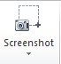

While you're viewing a document in the normal mode and you want to make it full-screen, simply press the **Alt + V keys at the same time on your keyboard**. Then immediately press the U button on your keyboard and your document takes up your entire screen.

Go to **Insert > Header or Footer**. Choose from a list of standard headers or footers, go to the list of Header or Footer options, and select the header or footer that you want. Or, create your own header or footer by selecting Edit Header or Edit Footer. When you're done, select Close Header and Footer or press Esc.



**On the Insert tab, click the Page Number icon, and then click Page Number**. Select a location, and then pick an alignment style. Word automatically numbers every page, except designated title pages. To change the numbering style, select Format and then choose the formatting you want to use.



Go to Insert > Text Box, and then select **Draw Text Box**. Click or tap in the document, and drag to draw the text box the size that you want. To add text to a text box, select inside the text box, and then type or paste text.



**Page Layout**



Apply a theme to quickly format an entire document and give it a modern, professional look. Select **Design > Themes**. Point to a theme to preview how it will look in your document. Select a theme.

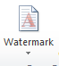

In Microsoft Office (like in many other suites of apps), a watermark is **a semitransparent text or image you can place in the background**. Usually, you use them to highlight something important about the document. For example, you can use it to remind the user that the content is confidential or draft

By default, Microsoft Word uses **white** as the default page color for all documents. If you'd like to use a custom color for your page, you can change page colors in Word.



**PowerPoint**





Transitions are **motion effects that when in Slide Show view add movement to your slides as you advance from one slide to another**. There are many transitions to choose from, each one of which allows you to control the speed and even add sound



Animation refers to **the movement and sound accompanying text or slides in your presentation**. Using animation with your lists and slides can often add excitement to your presentation by displaying text at crucial moments and making smooth transitions between topics.

**Excel**

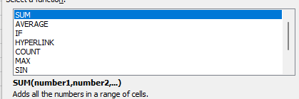 Functions

Functions are **predefined formulas that perform calculations by using specific values, called arguments, in a particular order, or structure**. Functions can be used to perform simple or complex calculations. You can find all of Excel's functions on the Formulas tab on the Ribbon: Excel function syntax.

**Pie charts can convert one column or row of spreadsheet data into a pie chart**. Each slice of pie (data point) shows the size or percentage of that slice relative to the whole pie. Pie charts work best when: You have only one data series. None of the data values are zero or less than zero.



Alternatively referred to as a formula box, the formula bar is **a section in Microsoft Excel and other spreadsheet applications**. It shows the contents of the current cell and allows you to create and view formulas

